SQL INJECTION
UNION Attack: Retrieving Multiple Values in a Single Column
PortSwigger Web Security Academy
Finding ID: SQLi-03

Report attribute | Value
Assessment category | Web application penetration testing
Vulnerability | UNION-based SQL injection
Affected functionality | Product category filtering
Affected parameter | category
CWE | CWE-89
Testing tool | Burp Suite Community Edition
Environment | Authorized PortSwigger training lab
Lab status | Successfully completed
Prepared by | Joshua Jesuraj Sanctus
Date | 1 November 2026

EDUCATIONAL ASSESSMENT
This report documents testing against an intentionally vulnerable training environment. It is not an assessment of a production application.

1. Executive Summary
This assessment examined a UNION-based SQL injection vulnerability in a product-category filtering function. The exercise was completed in PortSwigger Web Security Academy's intentionally vulnerable laboratory environment.
The testing demonstrated how a UNION query can be used to append attacker-controlled query results to the application's original result set. After identifying a compatible text column, the test retrieved multiple database values through that single column by concatenating usernames and passwords with a delimiter.
The lab was successfully completed, and the supplied evidence includes column-compatibility testing, the returned database values, and the completion confirmation.
The CVSS score in this report is an indicative estimate based on the impact assumptions stated below. It is not a score assigned by PortSwigger.

2. Scope and Methodology
Attribute | Details
Target | PortSwigger Web Security Academy — SQL injection UNION attack, retrieving multiple values in a single column
Functionality tested | Product category filtering
Parameter tested | category
Tool | Burp Suite Community Edition
Testing type | Manual request inspection and controlled SQL injection testing

2.1 Methodology
- Intercept the category-filter request using Burp Suite.
- Determine the number of columns returned by the original query and identify a column that accepts text.
- Use a UNION SELECT statement to append controlled query output.
- Concatenate multiple database values into one returned text column using a delimiter.
- Review the response and verify the lab's completion status.

3. Finding SQLi-03 — UNION-Based SQL Injection
Attribute | Assessment
Finding ID | SQLi-03
Vulnerability | SQL injection using UNION-based query manipulation
Affected parameter | category
Affected functionality | Product category filtering
CWE | CWE-89 — Improper Neutralization of Special Elements used in an SQL Command
CVSS v3.1 | Indicative; see Section 3.6
Status | Successfully completed

3.1 Description
The category-filtering functionality was vulnerable to UNION-based SQL injection. The technique allows an attacker to append the results of a second SELECT statement to the results of the application's original query, provided the SELECT statements have compatible column counts and data types.
The lab objective was to retrieve multiple values from the users table while returning them through a single compatible text column.

3.2 Vulnerability identification and testing
The category parameter was tested through an intercepted HTTP GET request. A UNION SELECT test was used to identify a column position that could return text.
'+UNION+SELECT+NULL,'abc'--
The response displayed the text value in the returned result, demonstrating that the tested column position could carry text data. The exact request syntax shown in the screenshot is preserved as evidence.

3.3 Data retrieval technique
After identifying a compatible text column, the query was modified to concatenate two fields from the users table. The captured request shows the following expression:
username||'~'||password
The double-pipe operator (||) concatenates strings in the database syntax used by this lab. The tilde (~) acts as a separator so that the returned username and password values can be distinguished within a single output field.
The request shown in the evidence uses a UNION SELECT statement with NULL in the other selected column position and the concatenated expression in the text-compatible position. The response contains multiple user records, including an administrator record.

3.4 Evidence and observations
The evidence is presented in chronological order: text-column compatibility testing, retrieval of concatenated user values, and successful lab completion.
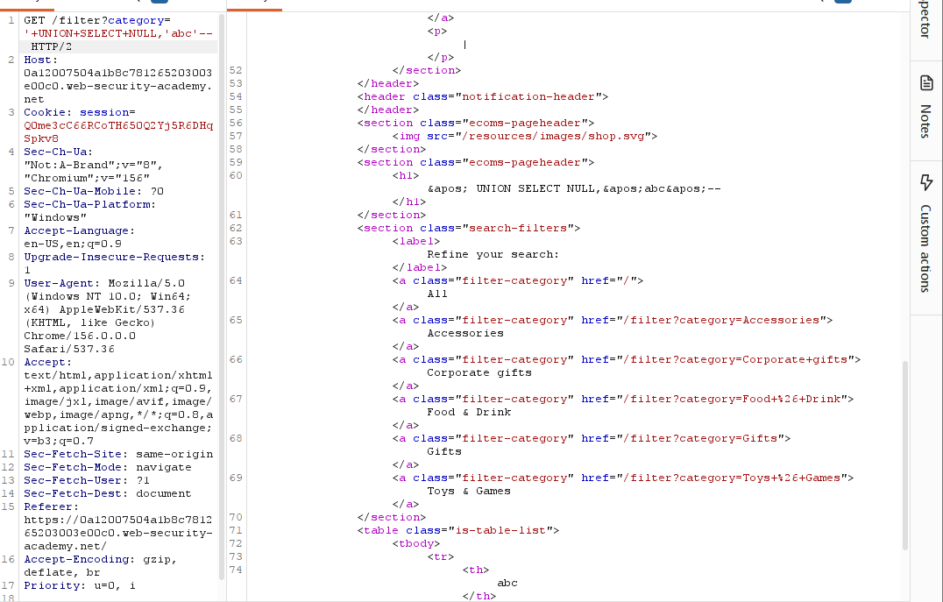
Figure 1. UNION SELECT compatibility test. The returned value 'abc' appears in the response, identifying a text-compatible output column.
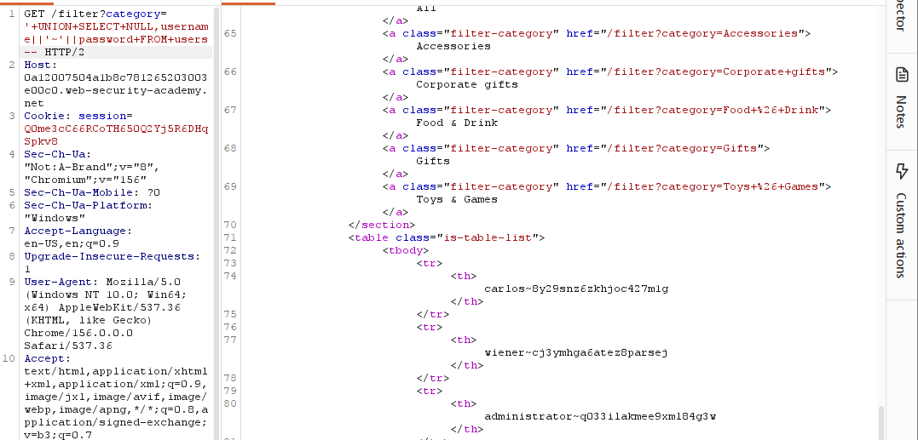
Figure 2. UNION query concatenating usernames and passwords into a single returned column.
The response displays values in the form username~password. The screenshot includes sensitive lab credentials and a session cookie; these must be redacted before public release.
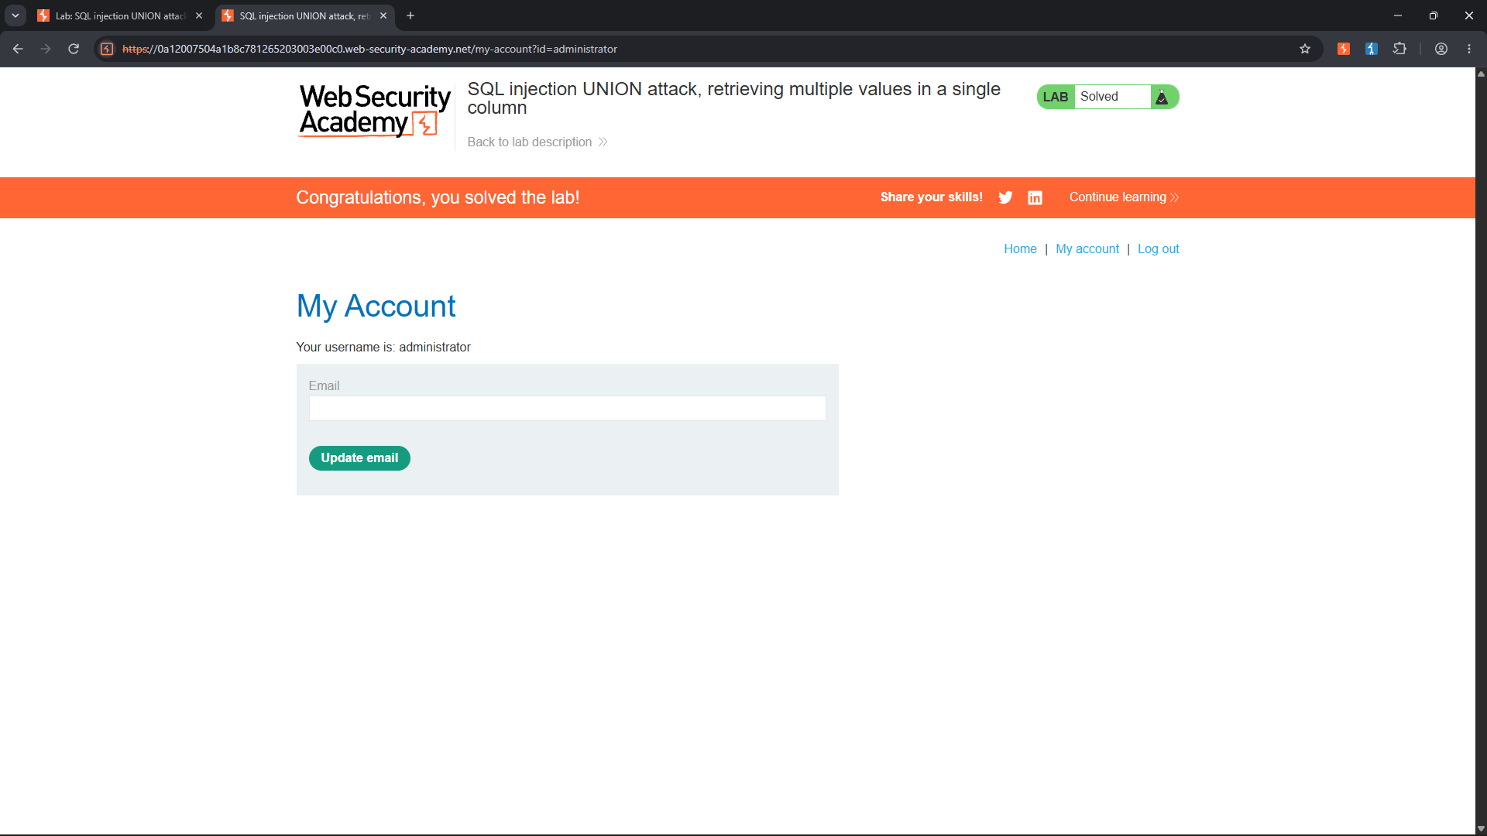
Figure 3. PortSwigger Web Security Academy lab completion confirmation and administrator account page.
The completion screen confirms that the lab objective was achieved. The displayed administrator account page is consistent with successful use of the retrieved credentials in the lab.

3.5 Security impact
- Unauthorized disclosure of information stored in the users table.
- Exposure of usernames and password values in the demonstrated lab environment.
- Potential account compromise if retrieved credentials are valid and reusable.
- Potential further access using accounts with elevated privileges.
The screenshot demonstrates credential values being returned by the lab. In a production application, the practical impact would depend on the sensitivity of the exposed records, password storage design, credential reuse, and privileges associated with the affected accounts. Passwords should not be stored in recoverable plaintext form.

3.6 CVSS v3.1 assessment
Indicative score: 8.2 — High
CVSS:3.1/AV:N/AC:L/PR:N/UI:N/S:U/C:H/I:L/A:N
Metric | Value | Rationale
Attack Vector | Network | The vulnerable parameter is submitted through an HTTP request.
Attack Complexity | Low | No special preconditions are assumed in the lab.
Privileges Required | None | The category-filter functionality is accessible without prior authentication.
User Interaction | None | No separate victim action is required.
Scope | Unchanged | The assumed impact remains within the vulnerable application.
Confidentiality | High | The demonstrated query returns usernames and password values from the users table.
Integrity | Low | Limited integrity impact is assumed from potential account access; destructive changes were not demonstrated.
Availability | None | No availability impact was demonstrated.

Scoring caveat: this score is an independent estimate, not an official PortSwigger rating. It assumes the exposed credentials are valid and that at least some could provide access to application data or limited account functionality. If credentials are non-reusable, securely hashed, or otherwise unusable, the confidentiality and integrity impacts—and therefore the score—would need to be reassessed. The lab evidence does not establish impact on a real production system.

3.7 MITRE ATT&CK mapping
T1190 — Exploit Public-Facing Application: a broad mapping for exploiting a vulnerability in an externally accessible application. This describes the exploitation context; ATT&CK does not assign a dedicated technique specifically to UNION-based SQL injection.
T1213 — Data from Information Repositories: a potential follow-on mapping where an adversary uses the vulnerability to collect information from a database. It describes the data-collection behaviour rather than the SQL injection mechanism itself.

3.8 Remediation
- Use parameterized queries or prepared statements for all database operations. Do not concatenate untrusted input into SQL statements.
- Validate category values against a strict allowlist of permitted categories.
- Apply least-privilege permissions to the application's database account and restrict access to user tables where not required.
- Never store plaintext or reversibly encrypted passwords. Store passwords using an appropriate salted password-hashing scheme such as Argon2id, bcrypt, or scrypt.
- Avoid returning sensitive database values to application responses.
- Implement monitoring for unusual query behaviour and repeated injection-like input.
- Include UNION-based SQL injection testing in secure code review and application security testing.

4. Conclusion
The lab demonstrated that UNION-based SQL injection can be used to append attacker-controlled query results to an application's original result set. By identifying a text-compatible column and concatenating username and password fields with a delimiter, multiple database values were returned through a single column.
The exercise highlights the importance of parameterized queries, database least privilege, secure password storage, and minimizing the exposure of sensitive records. The lab was successfully completed in an authorized educational environment.

5. References
- PortSwigger Web Security Academy — SQL injection UNION attacks
https://portswigger.net/web-security/sql-injection/union-attacks
- PortSwigger — UNION attack, retrieving multiple values in a single column (lab)
https://portswigger.net/web-security/sql-injection/union-attacks/lab-retrieve-multiple-values-in-single-column
- FIRST — CVSS v3.1 Specification
https://www.first.org/cvss/v3.1/specification.document
- MITRE ATT&CK — T1190: Exploit Public-Facing Application
https://attack.mitre.org/techniques/T1190/
- MITRE ATT&CK — T1213: Data from Information Repositories
https://attack.mitre.org/techniques/T1213/
- MITRE CWE-89
https://cwe.mitre.org/data/definitions/89.html
- OWASP — SQL Injection Prevention Cheat Sheet
https://cheatsheetseries.owasp.org/cheatsheets/SQL_Injection_Prevention_Cheat_Sheet.html

Assessment Disclaimer
This report documents authorized educational testing conducted against an intentionally vulnerable PortSwigger Web Security Academy lab. The findings and CVSS score are illustrative and should not be interpreted as an assessment of a production application or organization.

